Task 4
1st transaction
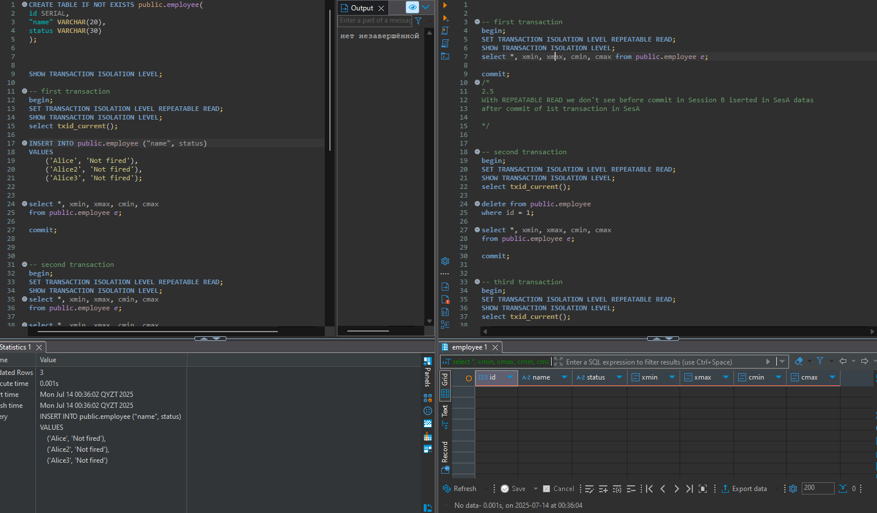
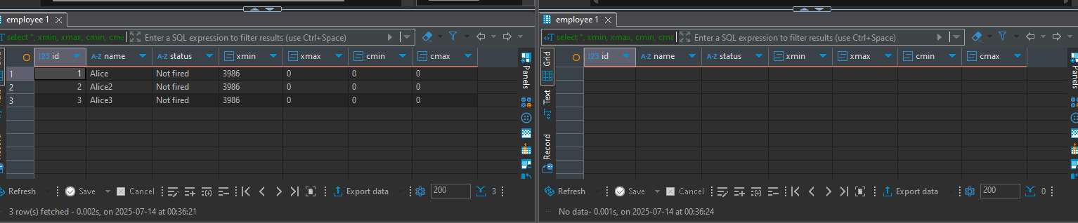
After COMMIT sesA
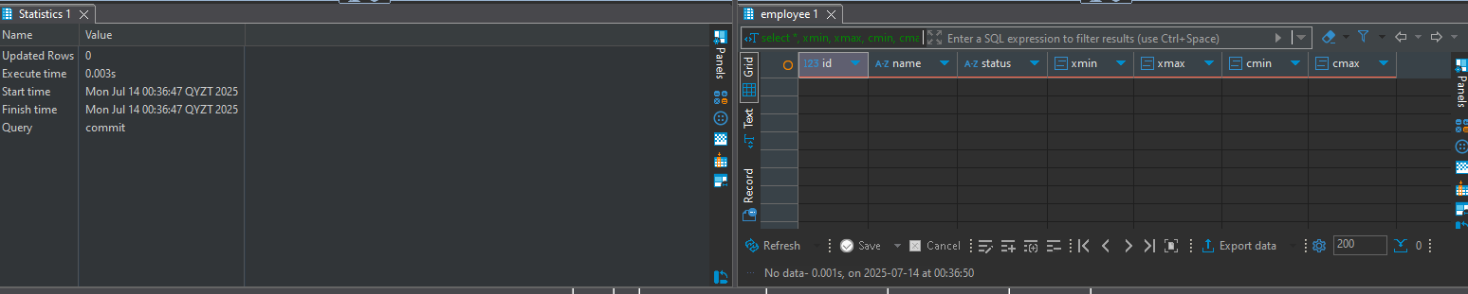
After commit sesB
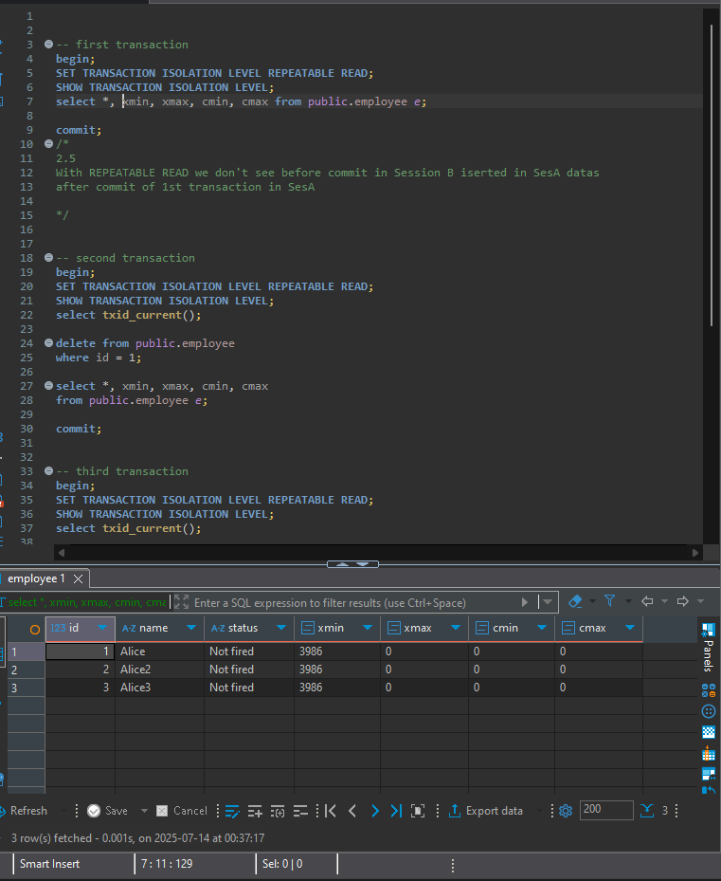
With REPEATABLE READ we don't see before commit in Session B iserted in SesA datas
after commit of 1st transaction in SesA
Only after both commits, in the new transaction we will be able to see any changes (insert in this case).
2nd transaction
SESA
select *, xmin, xmax, cmin, cmax
from public.employee e;
SESB
select txid_current();
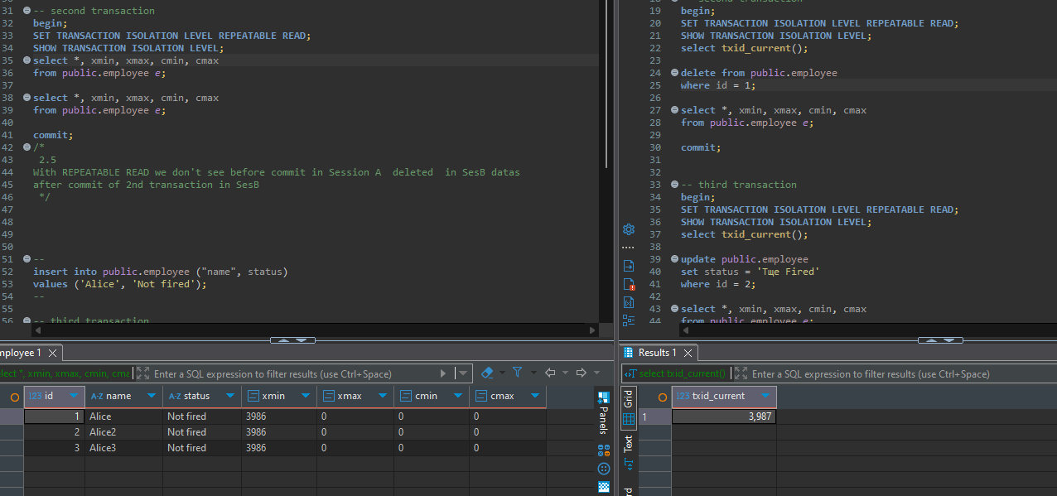
SESB delete from public.employee
where id = 1;
SESA select xmax changed but deleted row is still there because of repeatable read
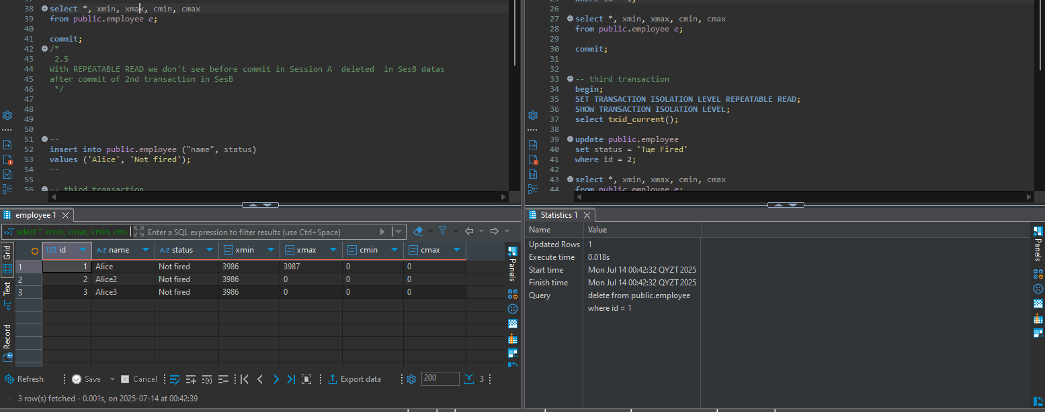
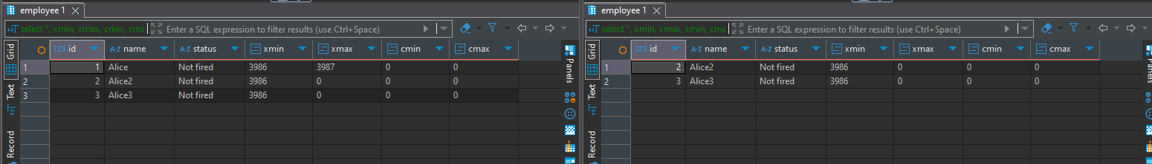
Only after both commits, in the new transaction we will be able to see any changes (delete in this case).

3rd transaction
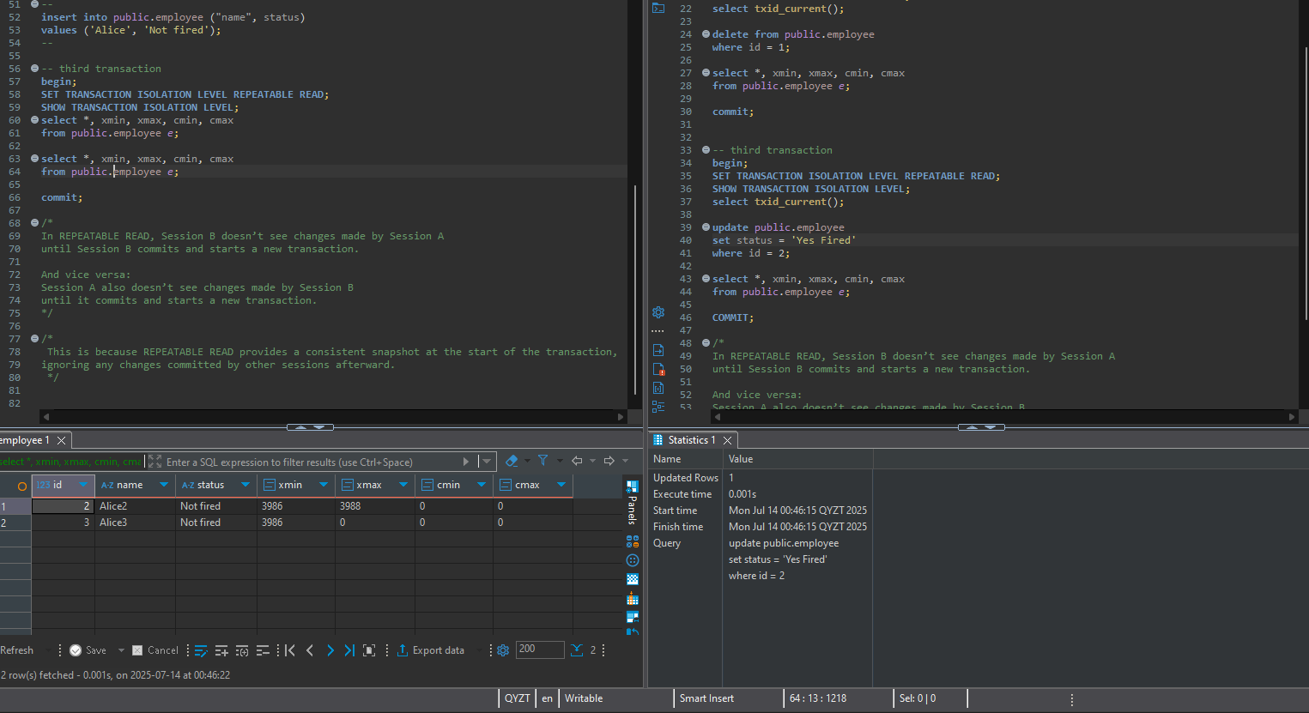
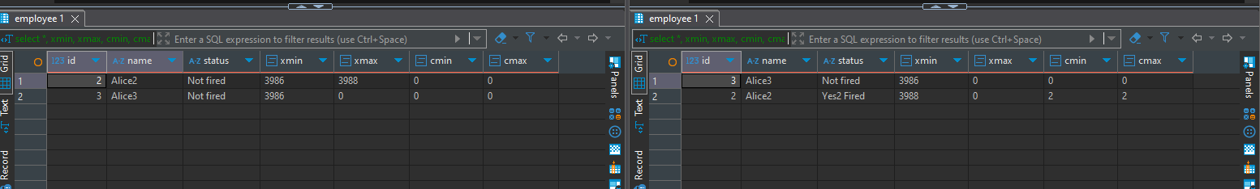

- Also here we can see cmin and cmax changed and they are = 2 (I did 2 update), so cmin and cmax track the command order of row creation and deletion within a single transaction.
Session B doesn’t see changes made by Session A until Session B starts a new transaction (after A has committed). And vice versa.

